|  |  |
| --- | --- |
| No. of Pages | **5** |
| No. of Questions | 8 |

**Department of Computer Science and Engineering**

**FINAL EXAMINATION SPRING 2014**

**CSE421/EEE465: Computer Networks**

**Total Marks: 90 Time Allowed: 3 Hours**

* Answer **Any** **Six (6)** questions out of **Eight (8)** questions.
* Figure in bracket [] next to each question indicates marks for that question.

## Question No. 1

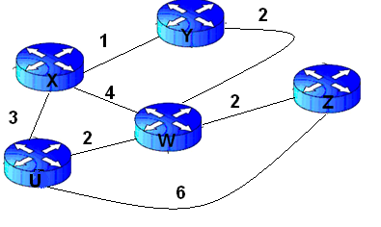

**Figure no. 1**

1. Link state routing protocol uses Dijkstra’s algorithm. Now using Dijkstra’s algorithm, compute the shortest path from Xto all other remote networks shown in figure no.1. Use the table provided. [ 6 marks]



**Figure no. 2**

1. Router1 was just successfully rebooted. Identify the current OSPF router ID for Router1 shown in figure no. 2 and explain why? [3 marks]
2. Why should you use the bandwidth command when configuring an interface of an OSPF router? [3 marks]
3. A router running OSPF has an O*E2 route. What is special about this route? [3 marks]

## Question No. 2

1. What are the advantages of using Distance Vector Routing Protocols? [2 marks]
2. A router has a RIP route to 192.168.4.0 in its routing table, with metric 3 hops. It receives information that the route is down, and it starts its holddown timer. [4 marks]
   1. What will it do if it now receives a regular update giving a route to 192.168.4.0 with 2 hops?
   2. What will it do when it receives no updates within 180 seconds, i.e when the timer runs out?
3. How will Router A shown in the figure no. 3 below, choose a path to the 10.1.2.0/24 network if RIPv2 routing protocol is running? What if EIGRP routing protocol was running instead of RIPv2? [5 marks]



**Figure no. 3**

1. Router 1 is running RIPv2, and the “auto summary” has been issued in Router 1 shown in figure no. 4. Which route/s will Router 1 advertise through its serial port s0/0? [4 marks]

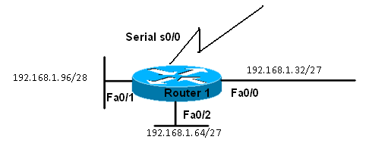

**Figure no. 4**

## Question No. 3

1. State at least 3 special features of EIGRP as compared with RIP or OSPF. [3 marks]
2. What is the advantage of EIGRP storing feasible successor routes as well as successor routes? [3 marks]

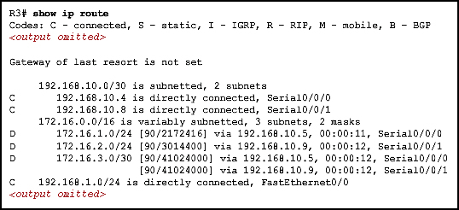

**Figure No. 5**

1. Refer to the exhibit shown in figure no. 5. Router R3 is using which routing protocol? And why are there two entries for the destination network 172.16.3.0/30? What is the value “41024000” indicate and how was it calculated? [6 marks]
2. Refer to the table above, what does the value 90 in the brackets mean? [3 marks]

## Question No. 4

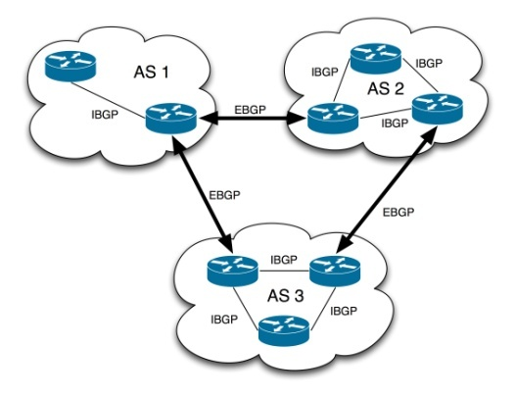

**Figure No. 6**

1. The Autonomous Systems shown in the above figure no.6 are of what type? [3 marks]

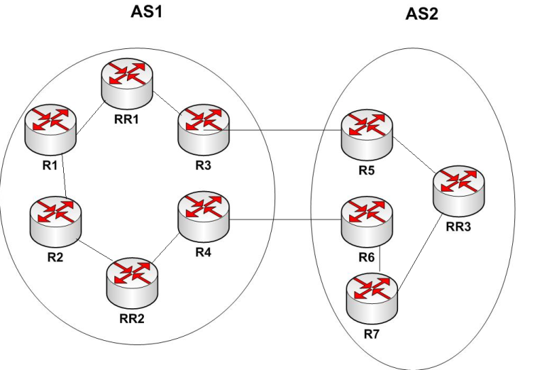

**Figure No. 7**

1. In figure no. 7, R1 wants to send some data to RR3. Which border router will it choose R3 or R4? Will it be the best choice? [5 marks]
2. When advertising routes, what are the main attributes or information that BGP helps to send from one router to another? [4 marks]
3. How does BGP prevent loops? [3 marks]

###### Question No. 6

1. TTL helps reduce congestion, how? [3 marks]
2. In “Traceroute” application, the originator sends the first packet with TTL=1 and continuously increments it and resends the packet. How does it know that the packet has reached the destination, that is how does it know when to stop? [4 marks]
3. Whenever we wish to test a connection to a device, we use the application “PING”, how does it work and which protocol is it based on? [4 marks]
4. Why does IPv4 must further fragment a packet? If fragmentation occurs how a receiver knows that it has received the last packet? [4 marks]

## Question No. 5

1. What is the difference between Implicit Signaling and Choke Packet congestion control? [4 marks]
2. A good acknowledgement policy means sending a single acknowledgement for multiple packets. True or false. Explain your answer. Is it open loop or closed loop? [4 marks]
3. After timeout, always slow start occurs, why? What happens to the window size? [3 marks]
4. What are the main four components that are required to use cookies in an ecommerce website? [4 marks]

###### Question No. 7

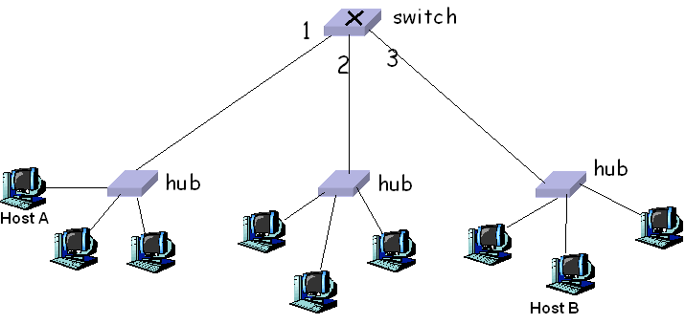

**Figure no. 8**

1. Host A sends a frame destined to host B, the switch receives the frame through port 1 in figure no. 8. How does the switch decide which port to send the frame through? How will the hub act in the sending and receiving of the frame? [4 marks]
2. What are the disadvantages of using “Polling” MAC protocol? [2 marks]
3. Differentiate between Routers and Switches. [3 marks]
4. During the ARP process, how does ARP cache of a host help? [2 marks]
5. In the CRC method, what steps does a receiver host follow with the received data and CRC bits? [4 marks]

###### Question No. 8

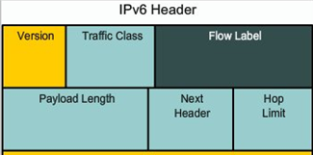

**Figure no. 9**

1. The above figure no. 9 represents the partial header of IPv6 (Source IP and Destination IP not shown). Explain the purpose of Traffic Class and Flow Label and did IPv4 have a similar header that is a header for the same purpose? [4 marks]
2. Broadcasts addresses are no longer present in IPv6, so how are we sending packets to all nodes or host in a network? [3 marks]

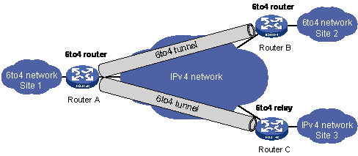

**Figure no. 10**

1. Explain how Router A is sending packets over IPv4 network to Router C in figure no. 10? [4 marks]
2. How is the Interface ID assigned using EUI-64 interface ID, that is how is the MAC of the device included in the interface ID part shown in figure no. 8? [4 marks]

##### THE END